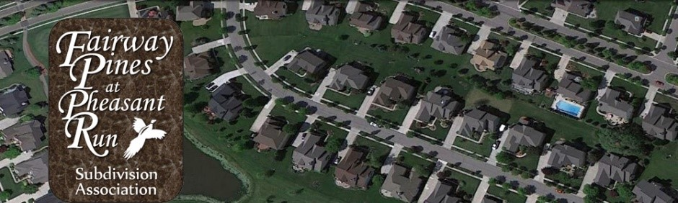

Fairway Pines at Pheasant Run
Board of Directors Meeting Minutes
May 26, 2022

Call to Order
- Meeting was called to order at 6:12 pm
- Meeting Attendees: Jon Anderson, Richard Rickert, Gelita Maxwell, Lana Levens and Michael Dawwas

Approval of Agenda
- Agenda was unanimously approved as is by all board members present

Board Updates Jon A.
- Richard Rickert – Fairway Pines Treasurer submitted his resignation effective May 26, 2022.
- Richard made a motion to nominate Mike Dawwas as new PRRMA rep and Gelita Maxwell for Treasurer. Motion was seconded by Jon Anderson. The vote passed by unanimous consent.

PRRMA Report Gelita M.
- Sidewalks repairs are underway. Email to residents was sent on Wednesday asking residents to not walk on sidewalks for 7 days.

Architectural Review Report Jon A.
- 13 letters have been sent to residents citing mostly grass cutting issues.
- Ask is to review neighborhood for potential violations for Jon to send letters.

Treasurer Report Rich R.
- Discussed process to have bank information transferred to Gelita along with additional signers.
- One outstanding check to Oakley needs to be written.

New/Misc. Business
- No new business currently.
Next Meeting: end of June (date and time TBD)
Meeting was adjourned at 6:44 pm

